First, two things that make Angular work:

NodeJS

- Open-source run-time environment built on Chrome’s V8 JS engine used to execute JS outside a web browser. We already saw this with JavaScript, and we need it in order to run Angular apps.
  - It provides a large library of various JS modules which can simplify development for web applications.
- NodeJS has definitely been used for development by pretty much any major enterprise you can name.
  - It’s used to create various applications like social media apps, video/text chat engines, browser-based games, and organization/collaboration tools.

Node Package Manager (npm)

- This is Node’s built-in package manager. It is similar to things like Scoop or Homebrew and allows for downloading and installing libraries for development.
“Angular and its dependencies are installed with npm, and it runs on a NodeJS server”
-If this quote makes sense to you, you have a basic idea of what’s going on under the hood
- CLI commands for Node Package Manager start with “npm”.
  - When you pull any angular project, you will likely have to run “npm install” to get all the dependencies. npm install is also a fun debugging trick like gradle refresh

*Installing NodeJS, npm, Angular* (If you aren’t on an FNMA environment)

-First, we need NodeJS. https://nodejs.org/en/download/
-Go ahead and check “Automatically install necessary tools”.
-Otherwise ”Next” your way through everything.
-A command prompt will show up, just do what it says. It’ll install a bunch of junk.
-...For a long time…
-Mcafee may stop it… should be fine.
-In git bash, enter: node -v to make sure it’s installed. It’ll tell you the version you have.

-npm has been installed too by the way!! Try npm -v to prove it. This shows the version of npm.

-Now we just need to set up Angular itself.
-In your command line tool of choice, enter: npm install -g @angular/cli
-Might get some deprecation warnings - it’s fine.

-ng version to make sure it worked. WOW! Cool art.

What is Angular?

- Angular is a front end framework designed by Google for developing Single Page Applications (SPAs).
  - An SPA is a webpage that gives the impression of being multiple pages that a user navigates through, but it’s actually a single webpage with “components” that move in and out responsively to change the user’s view.
- Angular Version History: Angular vs AngularJS
  - AngularJS was the first “Angular” in 2010 and was a JavaScript based SPA framework.
  - Angular 2 - 2016 A complete rewrite of the AngularJS framework in TypeScript.
    - Angular 2+ is generally used now to denote anything after AngularJS. So Angular 2+ will be relevant to us, AngularJS won’t be.
  - Angular 22 - the current version as of June 2026.
- Angular apps are fundamentally composed of Components and Services.
  - Components are sections of web pages that are easily added or removed to our base HTML web page, you can nest components inside other components.
    - Each component will have an HTML, CSS, and TS file associated with it.
  - Services are pure logic files. (Typescript files). They hold functions and variables that can be shared across components. We don’t need them in smaller apps, but they become very useful as you scale up.
- Angular has a very convenient CLI (Command Line Interface) that makes it easy to create new Angular apps and all of the moving parts within an Angular app.
  - Angular’s CLI commands start with “ng”
    - ng new to make a new application
    - ng generate component [folder-name]/[component-name]
      - And more!

Single Page Applications (SPAs)

- A Single Page Application (SPA) is a web application that fits on a single page in the browser. All our JS, HTML, CSS code is retrieved by the browser in a single page load.
  - Navigation between “pages” is performed without refreshing the page - we simply render different components depending on the URL (see Routing below!)
  - So with Angular, we don’t navigate between pages at all. The webpage is like a canvas/whiteboard with parts moving in and out as the user navigates.
- Most enterprise-level webpages you visit are SPAs these days!

SPA Advantages
- Fast and responsive. Since an SPA only updates the required content, we don’t have to wait for an entire page to load when navigating.
- High Caching capabilities. The page will cache all received data locally, which then can be reused even if offline. If the user has limited connectivity, local data can be synchronized with the server when connection allows.
- SPAs are very popular, so frameworks like Angular are fairly well documented despite some pretty drastic changes between versions.
SPA Disadvantages
- While overall performance is better, more data is frontloaded (loaded in the beginning) so the first page load can be slower.
  - Ever notice how long Gmail or YouTube take to load?
- Does not perform well with Search Engine Optimization (SEO), which is ironic because google designed this stuff.
  - SEO is basically how you ensure your website is as high on the list of results returned by a search engine.
- Security - SPAs have some increased vulnerabilities to Cross-Site Scripting (XSS) attacks.
  - XSS is a bad actor (like a hacker) inserting malicious JS into the page load from a third party location.

TypeScript Refresher

- TypeScript is the language we’ll use to provide functionality to our Angular front ends, essentially replacing the role of JavaScript.
  - TypeScript is a superset of JavaScript (Superset - A programming language that contains all the features of a given language and has been expanded or enhanced to include other features as well.)
- All valid JavaScript (JS) is valid TypeScript (TS). But the reverse is not true.
  - TS must be “transpiled” into JS for a browser to run it. Browsers do not have built-in support for TS.
    - “Transpiling is a specific term for taking source code written in one language and transforming into another language that has a similar level of abstraction.”
    - So while Java COMpiles into bytecode, TS TRANSpiles into JS.
- TS is open-source, object oriented, portable, strongly typed
  - OOP - it supports classes, inheritance, interfaces etc. MUCH easier than we could with JS.
  - Portable? Means you can use it in different environments
  - Strongly typed - When you declare a variable, you need to declare a type.
  - TS files have the file extension “.ts”
===Angular Project & Component Creation Syntax===

First, open a command line terminal where you’d like your project to be
run ng new your-app-name --skip-git (this creates a new project)
--skip-git will bypass the automatic creation of a git repo

ng serve -o (to run an angular app and open it on a browser tab)

*On initial render, we get sent to the default welcome page with good tutorials and docs

You can run npm install to get dependency updates, and you’ll NEED to run it to install the dependencies (in node_modules) if you pull an Angular project from github.

ng generate component components/[component-name]
(generate a new component in a folder called components)

*To stop the app’s runtime, the keyboard shortcut is ctrl + c.

Angular File Structure

- node_modules - this is where all the dependencies for your angular project live.
  - npm determines dependencies via the package.json file and the package-lock.json file. (Similar to the build.gradle file)
  - The autogenerated .gitignore file will automatically ignore the node_modules folder. So the dependencies don’t get pushed to git repos…
    - “npm update” or “npm install” is needed to install the appropriate dependencies to the node_modules folder after the code is pulled or cloned from an online repository. Much like a maven update!!
- src contains source code files, which is where we’ll be doing most of our coding. This is where our custom components, services, logic, etc will all go.
  - app - this is where all your components live. It comes with a root component called app.component. This contains a lot of our baseline web page structure.
  - app.component.ts - root component’s typescript file – logic, variables, and imports can go here. Just like in any other component.
  - app.component.html - is the root component’s html template
  - app.component.css - is the root component’s css file.
  - app.component.spec.ts - auto generated testing file for the root component.
  - app.routes.ts - A class that holds an array of all the routes in our project.
- public - holds images or other resources.
- favicon.ico - the icon that gets displayed in the browser tab.
- index.html - The main html page that is served when someone visits the website. Our components will be moving in and out of this index.html file as the user clicks around. We won’t edit this but it’s important to know about.
- main.ts - main entry point for the application. Analogous to Java’s main method. We won’t really mess with this either.
- styles.css - this is the “global” stylesheet for the project. This styling will be applied to the index.html and all components.
  - Just remember that each component also has its own .css file, which will only apply to that component in particular.
- tests.ts - entrypoint when running tests.
- angular.json - this holds the CLI configuration defaults for the project. It includes options for building, serving, and testing the project.
  - So when you run something with the CLI, this is what it checks in order to run.
Angular Components

- Components are a “section” of a webpage that can be displayed or removed by our Angular application. Think of all the different sections displayed in a typical website. Newsfeeds, navbars, ads, sidebars, etc.
- We can use the CLI to create a new component in our Angular application. The command to create a component is “ng generate component <component-folder (optional)> <component-name>.
  - This can be shortened to “ng g c <component-folder> <component-name>”
  - Creating a component through the CLI creates four files that make up the component: html, css, spec.ts, ts
- We can display components in two ways:
- Statically - Each component will have a selector associated with the @Component decorator. An HTML tag in the app.component.hml can be named the same as that selector to display that component on your webpage statically. This isn’t incredibly dynamic though… The point of angular is to have components constantly moving in and out.
  - You might have some statically rendered components, like headers or navbars.
- Dynamically - A component can be placed in the “routes” array of the app-routing.module as an object with “path” and “component” fields.
  - This lets out components move in and out dynamically, triggered by events like a user clicking around. Read more about Routing below!
- Every Component will have the @Component decorator, which turns a class into a component. It specifies the selector, the html page, and the css sheet associated with the component.

Standalone Components and NgModule
(friendship ended with NgModule)

- In the past (until 2024-ish), we organized related parts of our Angular application with something called NgModule.
  - It was declared with the @NgModule decorator, found in a file called app.module.ts.

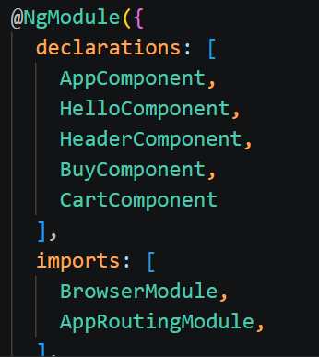<- The entity would have looked something like this
- This allowed for modularity, at the cost of having an extra file to manage. Whenever you created a new component or imported a new library, it had to be added to the NgModule. The Angular CLI mostly took care of this for us, but it still contributed to Angular’s notorious application bloat.
  - If you’re working on an Angular app that was built pre-2024, you’ll likely be dealing with this. You WILL most likely be working on older codebases as you begin your career, so recently-deprecated stuff like this is good to know about.
- Standalone Components are the new norm as of Angular 17. Now, components declare their own imports. Every component’s TS files will start with something like this:
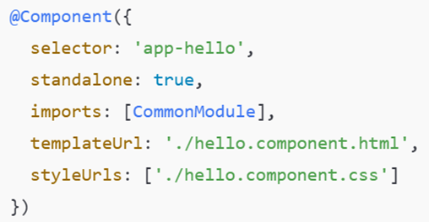

- Selector: The <name/> we use when rendering the component onto the page
- Standalone: Not required as of Angular 19 - standalone is now default.
- Imports: Any libraries or components to be used in this component.
- TemplateUrl: The HTML file (AKA the template) associated with this component.
- StyleUrls: Any stylesheets used in this component. This lets you directly style an individual component

Webpack (a bit about how Angular used to work under the hood)

- Webpack is a powerful static module bundler for JS applications that packages all modules in our application into a bundle and serves it to the browser.
  - It “packs” the application up to get served to the browser for easy rendering and quick app performance, at the expense of a longer load time.
- Angular USED TO use Webpack as a dependency, but the framework moved away from Webpack after Angular 17. It was an eventful update.
  - Webpack’s deprecation is the main thing I want to note here. If I try to use an older Angular app with a modern version of NodeJS or Angular CLI, it won’t work. It’ll be a total headache actually, ask me how I know.
    - After some research online, the best solution is “get over it and paste your old code into a new Angular app if you really want to use it.” Great thanks.

Data Binding
- In Angular, data binding lets a component’s HTML and TS files communicate. In other words, data binding lets us share data between a component’s logic (TS) and its view (HTML).
  - Most of the functionality in our components rely on data binding in some form. Just like how JS and HTML need to communicate in a more oldschool webpage.
- It’s called Data Binding because we “bind the data” from a component’s HTML to its TS or vice versa.
There are TWO DIFFERENT KINDS of data binding: One-way and Two-way
One-way Data Binding
- Allows us to manipulate the view (what the user sees - the HTML) through references to members of the component’s TS files. In Angular, there are three types of one way binding
- String Interpolation (often just called interpolation) - This displays the value of a component’s TS variable as text in the HTML.
  - Syntax is two curly braces: {{var name}} in the HTML
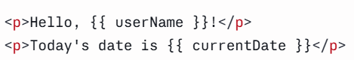
The TS file has userName and currentDate, which these refer to.
- Property Binding - This binds values of component variables to the attributes of HTML element attributes.
  - Syntax is square brackets: [attribute] = “variable name” in the HTML tag
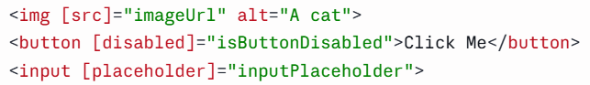
The TS file has imageUrl, isButtonDisabled, and inputPlaceholder, which these refer to
- Event Binding - This allows us to bind DOM events such as button clicks, mouse overs etc, to a function in the component. Similar to how event handlers/listeners work in plain JavaScript.
  - Syntax is parenthesis: (event) = “function name” in the HTML tag
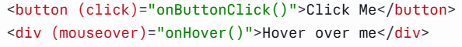
The TS file has the onButtonClick() and onHover() functions which these refer to

- Two-way Binding combines property binding and event binding together. It is very useful for collecting user input!
  - Syntax is “banana in a boat”: [(ngModel)] = “variable name”
What’s going on here? There are two different input boxes. One is bound to a TS variable called “username” while the other is bound to “password”. Maybe some kind of login page?

NOTE: Two way binding requires us to import the FormsModule in the imports section of the component before it can be used. We’ll see this every time we need it.

Angular Directives

- Angular Directives provide functionality for dynamic DOM manipulation in our HTML. In English, they let us conditionally and dynamically render stuff on the page.
  - The directive is a marker on a DOM element (in the HTML) that tells Angular to change the appearance, behavior, and/or layout of an element and its children. Generally, they begin with “ng”. They will be your best friend when it comes to writing dynamic rendering functionality for your webpage.
The two types of Directives we’ll talk about are Structural Directives and Attribute Directives
- Structural Directive: These change the structure of the DOM elements. They are declared generally with a star - *ng.
  - E.g. *ngIf, *ngFor
- *ngIf - renders an element (or not) based on a boolean expression
  - Good for conditionally rendering something on the page.
- *ngFor - repeats a part of the HTML template for each item in an iterable list (generally an Array)
  - Good for rendering multiple things on the page.
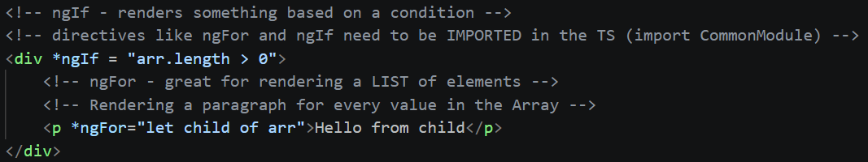
- Attribute Directives: These change the look or behavior of an element. They change the ATTRIBUTES of DOM elements
  - E.g. ngModel, ngClass, ngStyle, (we’ll mostly only use ngModel)
- ngClass - used to change the class of an HTML element to the value of the variable/expression you associate it with.
[code snip of this from our demo]
- ngStyle - Used to change the style attributes of an HTML element based on some value in the TS.
*The (click) event fires a function that changes the headerColor variable
The idea is that HTML class and style attributes are easily changeable when we use ngClass or ngStyle. Instead of having to do the classic document.getElementById(), getAttribute(ClassName), THEN change the value... you can change the value based on some variable in the TS.

Example with Two Way Binding – A user is prompted to enter a username:
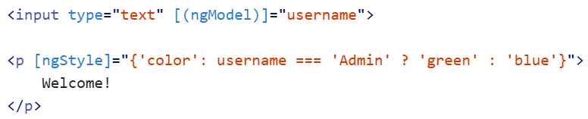
(What’s happening here? Based on the username input, the text color will change, thanks to ngStyle. Note: remember two-way binding is used to take user input!)

ngSwitch - combines both attribute and structural directives

- The ngSwitch directive will create an element in the DOM based on a switch statement. (Thus changing the DOM structure).
  - The statement itself is an attribute of the element, so it’s considered both a structural and attribute directive. Don’t think too hard about it, it’s easy to use.
- ngSwitch works very much like a switch in Java! You’re building a switch statement directly into your HTML page.
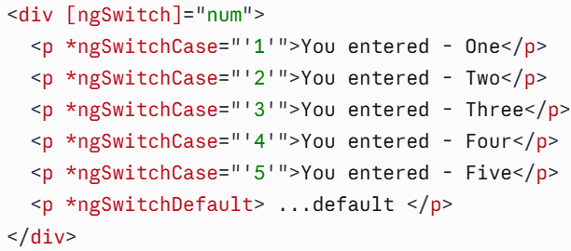
- Side Note: Custom directives can be created using the Angular CLI. The command is: ng generate directive <directive-name>. I won’t get into these but feel free to research.

Sharing Data between Parent and Child Components

- If you don’t plan to set up a Service (read below) for global data/function sharing, you can send data directly between parent and child with @Input and @Output.
  - @Input: Send data from a parent to a child. A value gets passed to the child when it’s rendered in the parent’s HTML.
    - (Not dropping an example here cuz we’ll see this in the demo)
  - @Output: Paired with an EventEmitter object, this allows the child to emit data back to the parent.
Here’s an example of @Output between parent/child since we won’t see it in the demo:
(Note the HTML directly defined in the TS files)
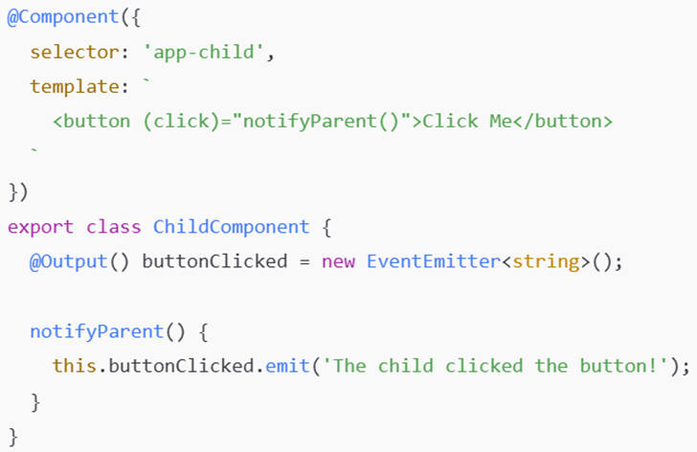

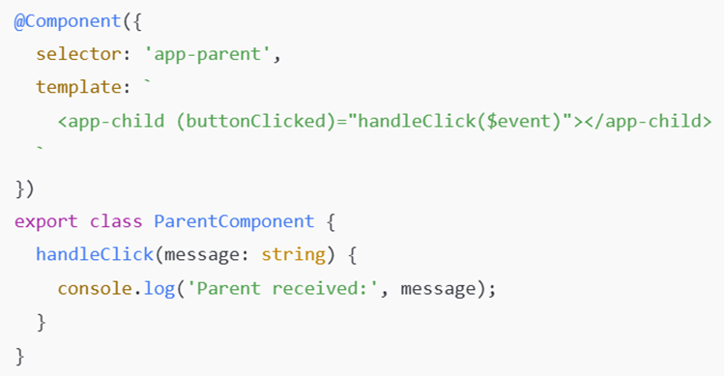
The parent renders the child component and listens for a button click
This lets the parent listen for the event that gets emitted by the child on button click.
Then, whenever the child’s button it clicked, the event gets emitted to the listening parent
*Basically, handleClick() on the parent gets invoked once notifyParent() in the child gets invoked. The parent function gets some String data from the child component’s invoked function. It’s a bit harder to wrap your head around than @Input, and less commonly used.

Routing

- In a Single Page Application, when a request is sent to the server, only a single page is returned, as we already know.
  - However, we can emulate the experience of browsing multiple pages to the user, using routing.
  - “Routes allow for the navigation from one view to another, by changing what components are displayed.”
- Go find the routes array in the app.routes.ts, we stick our components in here in order to route them and display them dynamically!
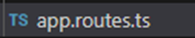<---This guy
- To allow for navigation in app.routing.module, we specify objects in the routes Array. Each object will define a path and component:
  - Path - the url endpoint in the browser that we’re routing to a particular component
  - Component - is the class name of the Component we want to render.
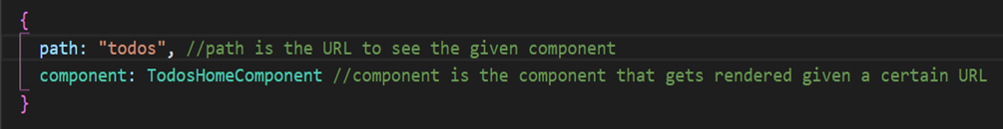
- Then we tie it all together including the <router-outlet> tag in the app.component.html. Routing won’t work if we don’t include that!
  - Routing comes from the RouterModule library, which is included in modern versions of angular. We used to have to install it manually when creating a new app, with the --routing tag.
Routing Strategies
- RouterLink
  - Thus far, we’ve had to manually change our URL to see different components
    - But using the RouterLink attribute in our HTML elements, we can show and hide components with the click of a button
- Route Guards
  - Angular has functionality for “guarding” certain routes in our application’s routing. Essentially, routes can be labeled as only accessible to certain users.
  - Route guards exist as a way to design security into your application!

Services

- Services are used to organize and share business logic, models, data, or functions with different components of our Angular application.
  - Services play a big role in giving our components shared functionality.
“An Angular Service can be injected into multiple Components, so each Component can access the Service’s fields and functions.” Similar to how importing Classes works in Java.
- This makes for very reusable code! You can inject one service into multiple components, and one component can inject many services.
  - This is an example of Dependency Injection! (DI)
  - Services are fundamentally tied to Dependency Injection in Angular. So much so that they use the @Injectable decorator to identify them.
- Generating a Service is easy with the CLI:
  - ng generate service services/<service-name>
  - OR ng g s services/<service-name>

Dependency Injection (DI)

- Dependency Injection it’s a design pattern where the class receives its dependencies (its data/functionality) from an external source instead of creating them itself.
  - Dependency Injection does not use the “new” keyword. We declare all of the necessary members (data/functions) in one class (the service) and give them to the injectee (the component)
Constructor Injection: We tell our application in the constructor what dependencies we need and it will provide them when we create the object. Angular uses EXCLUSIVELY Constructor Injection
*Angular doesn’t use Setter/Field injection like Spring*
Constructor injecting a Service into a Component. It populates an array of Employees.
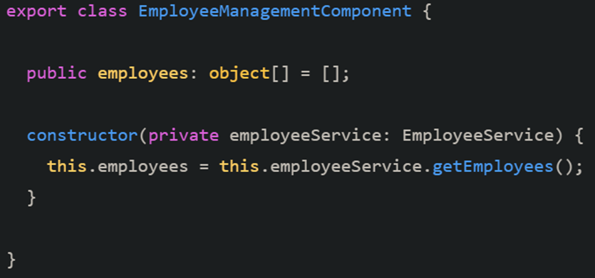

Publisher/Subscriber Design Pattern
- Pub Sub is a design pattern for sending messages between applications. We use it in our angular apps when we send HTTP requests.
  - A publisher creates and pushes messages to a channel (which is basically a continuous of stream of data)
  - The subscribers who subscribe to this channel/stream are immediately notified when new data gets published.
    - The subscriber then decides what to do with the message from the publisher. It will get the data the publisher is publishing, and do something with it.
*magazine analogy* A magazine publisher constantly publishes issues of a magazine, and sends them off to the mailbox of people who have a subscription. A subscriber can get the magazine from the mailbox, and use it for whatever they wish (get info? do nothing with it?) A subscriber can unsubscribe at any time, and will no longer get magazines from the publisher.
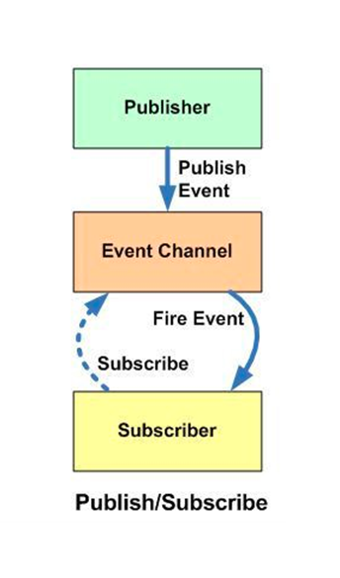

*When your phone get a push notification, that’s publisher subscriber too!

- There is a sub-design pattern called the Observable Pattern, which is what Angular uses more directly. Angular uses this design pattern with the HttpClient Module (see below) to manage HTTP requests.

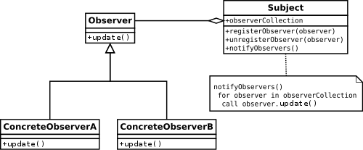

We have a Subject (event channel) that maintains a list of Observers (subscribers). It notifies the observers of any new published messages.
Observables

- Provide support for passing messages/information between parts of your application. They can be used for event handling, asynchronous programming, and handling multiple values. We will most often see them with HTTP requests.
  - Observables are the publishers in the publisher/subscriber design pattern (see above). This means our components must subscribe to an observable object in order to get information from it.
- Once you’ve obtained the resources you want from an observable, you can “unsubscribe” from the observable.
  - You can do this even if you haven’t received anything. Subscription is at will.
- Observables have three callback methods happening under the hood, that we can implement ourselves if we want specific things to happen:
  - next() - next is called when new values enter the stream, (a new resource/message is produced). When the publisher that is being observed publishes a value, as long as it’s not an error, the observable will call this method to emit the value.
  - error() - is called if an error occurs
  - complete() - when the stream completes returning values
Promises vs Observables? Two major differences.
- A promise can only emit a single value, while observables can emit many
- Promises must return/fulfill the promise (they must complete) while observables can be unsubscribed from any time.

RxJS (Reactive Extension for JavaScript)

- “A framework for reactive programming (programming that relies on events happening) using observables that make it easier to write asynchronous code.”
  - This is the library we’ll be using/importing in order to use observables!!!
- RxJS Subjects are a special type of Observable that allows values to be multicast to many observables. (This just means we can send values to many places at once)
  - Look back at the diagrams - Subjects are our event channels that Observers are watching in order to get messages from Observables.
  - Subjects have a notify() method that allows them to notify all the observers that are watching them.

HttpClient - Allows HTTP requests/responses in Angular

- HttpClient is a module built into Angular that provides functionality for HTTP requests and responses. (Hopefully the name makes this apparent)
  - Typed request and response object (e.g. request type, response type)
  - Built in Observables API for asynchronous coding
  - Built in error handling
  - Testing features
- It’s imported from @angular/common/http, You will need to include the HTTPClient provider in app.config.ts to use HTTPClient!
Methods (should be recognizable)
- request() - generic request
- get()
- post()
- patch()
- put()
- delete()
- head()
- Etc.
- HttpClient has an HttpHeaders service class that is used for configuring headers of a request. You may need to look into this if you start getting CORS errors when trying to GET or POST from your Java server.
  - The HttpClient, along with RxJS’s catchError function, allows easy error handling within each service that uses HttpClient.

Angular Pipes
- Pipes provide a way to transform values in our Angular template (HTML) files. They use the pipe character “|” and take in data to reformat it.
  - For example, let’s say a date is shown in this format: Sat Aug 03 2019 19:48:11 EST+0530 (Eastern Standard Time)
    - A pipe can turn it into: Saturday, 03 Aug 2019 07:50 PM
    - Syntax: {{<var name> | <pipe name>}}
      - Eg {{name | uppercase}} //will turn “name” all uppercase
Angular has plenty of built-in pipes. There are pipes for:
- Date
- Decimal
- Currency
- Percent
- Lowercase/Uppercase
- TitleCase - makes every word begin with a capital letter
- Json
You can create your own custom pipes too:
- CLI command is: ng g pipe <pipe-name>
  - Pipe classes use the @Pipe decorator while implementing PipeTransform.
Signals
- Signals let us listen for changes in application state and execute some code when changes occur.
  - “Application state”? Just a fancy way to say the data stored in the app at a given point in time. If a user logs in to the app, app state will change as we store that user’s info locally.
    - Signals are often not necessary unless you’re dealing with very time sensitive functionality like stocks or ticket sales.

There are two flavors of Signals:

- Writeable: This is a Signal that we can set and update at will. Hence the name “writeable” as in “write access”.
  - We use the signal() function to create one
  - You can use set() to set the value directly
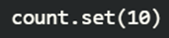
  - Or use update() to define a function that changes the value

- Computed: This is a signal that is calculated based off of other signals. We can’t update it directly.
  - We use the computed() function to create one. Here’s we’re calling back to the “count” signal from the example above
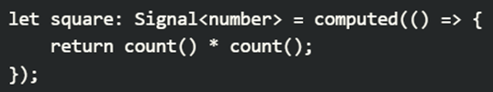
Now, whenever count() updates, square() will as well.

- Once we’ve written a signal, we can define some code to execute with an effect. Just call the effect() function and indicate what signal to listen for:
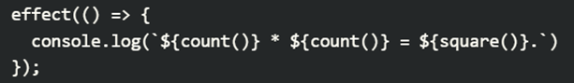
This effect() will log the new count/square values whenever either of them change.
Think of the “side effect” of these variables changing.

Component Lifecycle Methods
- Angular components have a lifecycle defined by 9 phases a component goes through when rendered on the webpage. We can “hook” into these phases to execute code when they occur. Some examples include:
The Constructor
- Technically a component lifecycle method, this executes before any of the other lifecycle methods listed below. This is where you inject dependencies like services or import other components that need to be present before the component renders anything.
NgOnChanges()

- Lets you define code to get invoked whenever a component’s @Input properties change.
NgOnIt()
- Lets you define code to get invoked on initialization of the component. (When it first renders, after the constructor is done)
NgAfterViewInit()

- Lets you define code to get invoked once the component is done rendering the HTML (AKA what the user sees – the “view”)
NgOnDestroy()

- Lets you define code to get invoked on teardown of the component (When it gets de-rendered off the screen)

Plus some more! You can look at the curriculum for more (there are 9 total), but these are some of the main characters.

Getting ngx-bootstrap and ngx-toastr in your Angular app-------

Run these installs: (you can just copy and paste this into the terminal)
npm install ngx-bootstrap@21 bootstrap
npm install ngx-toastr
npm install @angular/animations@21

Add these to the styles array in angular.json:

"./node_modules/ngx-bootstrap/datepicker/bs-datepicker.css",
"./node_modules/bootstrap/dist/css/bootstrap.min.css",
"node_modules/ngx-toastr/toastr.css"

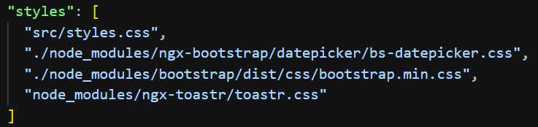
Finally, add the toastr provider in app.config.ts

provideToastr()

